**What is the total amount each customer spent at the restaurant?**

select customer_id,sum(price) as total_spent from sales inner join menu

on sales.product_id =menu.product_id

group by customer_id;

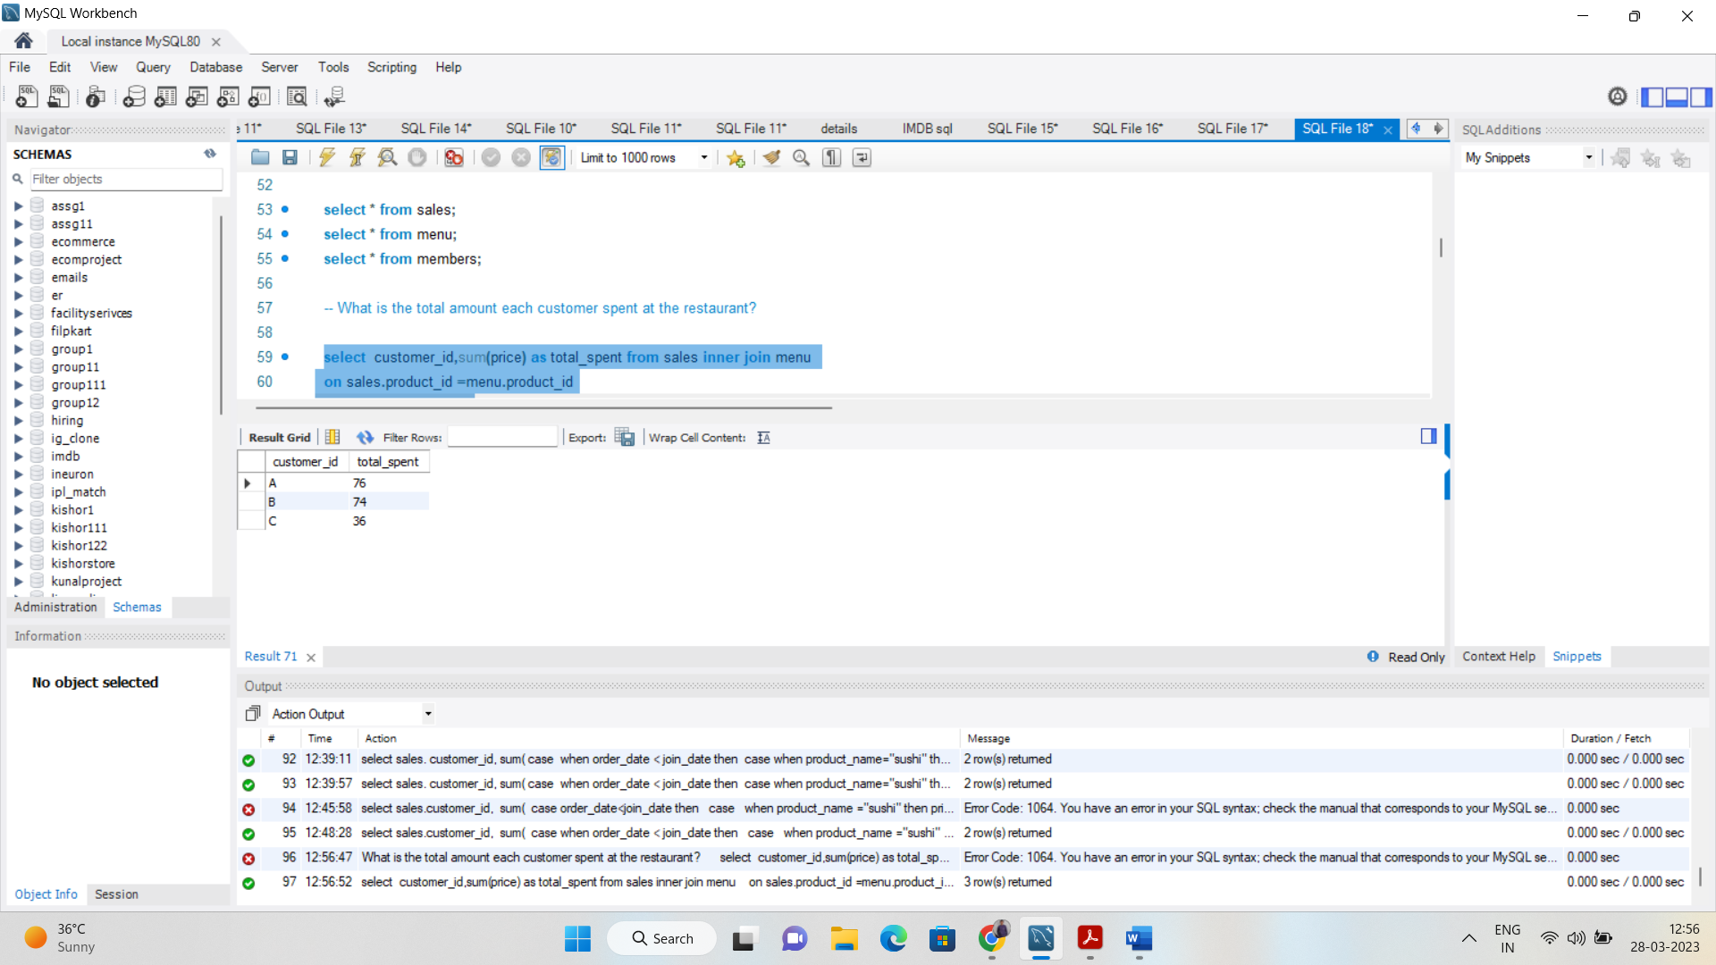

**How many days has each customer visited the restaurant?**

select customer_id,count(distinct(order_date)) as no_of_days from sales

group by customer_id

order by no_of_days desc;

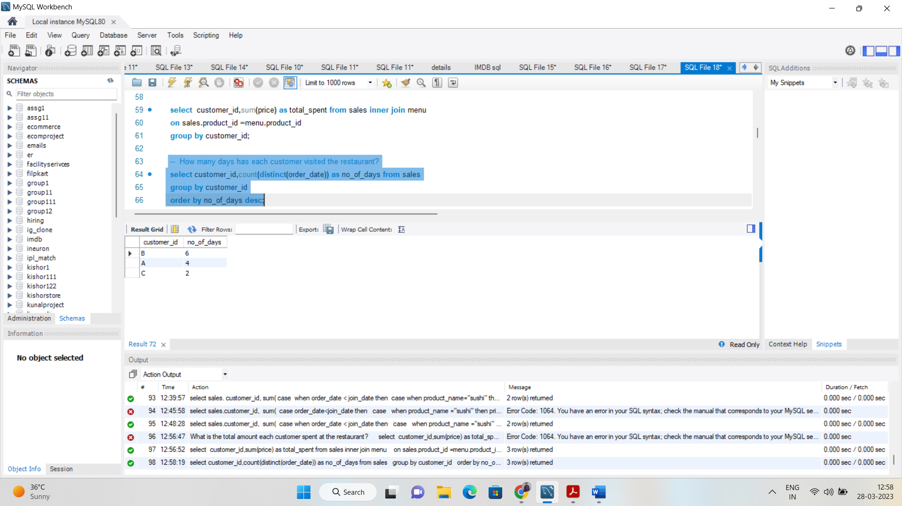

**What was the first item from the menu purchased by each customer?**

with t1 as

(select customer_id,product_name,row_number() over (partition by customer_id order by order_date asc, sales.product_id asc) as rn from sales

inner join menu

on sales.product_id =menu.product_id)

select customer_id,product_name from t1 where rn=1;

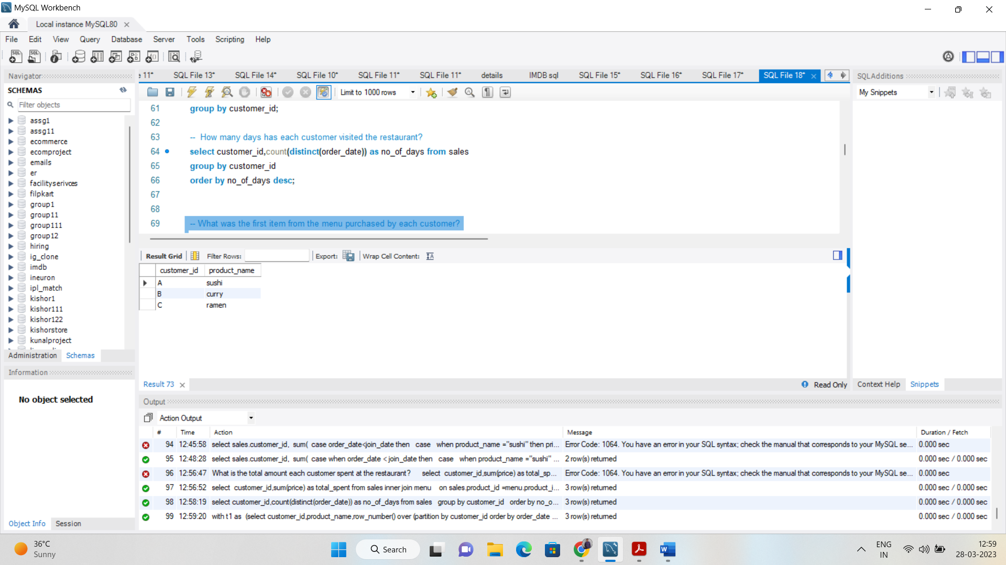

**What is the most purchased item on the menu and how many times was it purchased by all customers?**

select product_name,count(sales.product_id) as most_tyms from sales inner join menu

on sales.product_id=menu.product_id

group by product_name

order by most_tyms desc

limit 1;

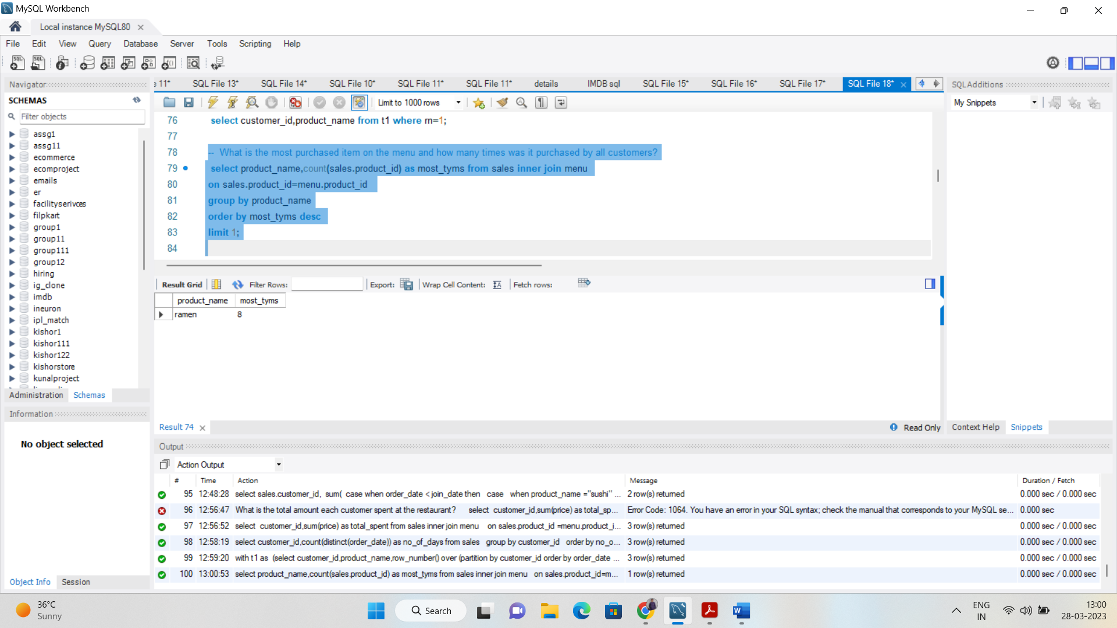

**Which item was the most popular for each customer?**

with t1 as(

select customer_id,product_name,rank() over (partition by customer_id order by count(sales.product_id) desc ) as rnk from sales

inner join menu

on sales.product_id=menu.product_id

group by sales.customer_id,product_name)

select * from t1

where rnk=1;

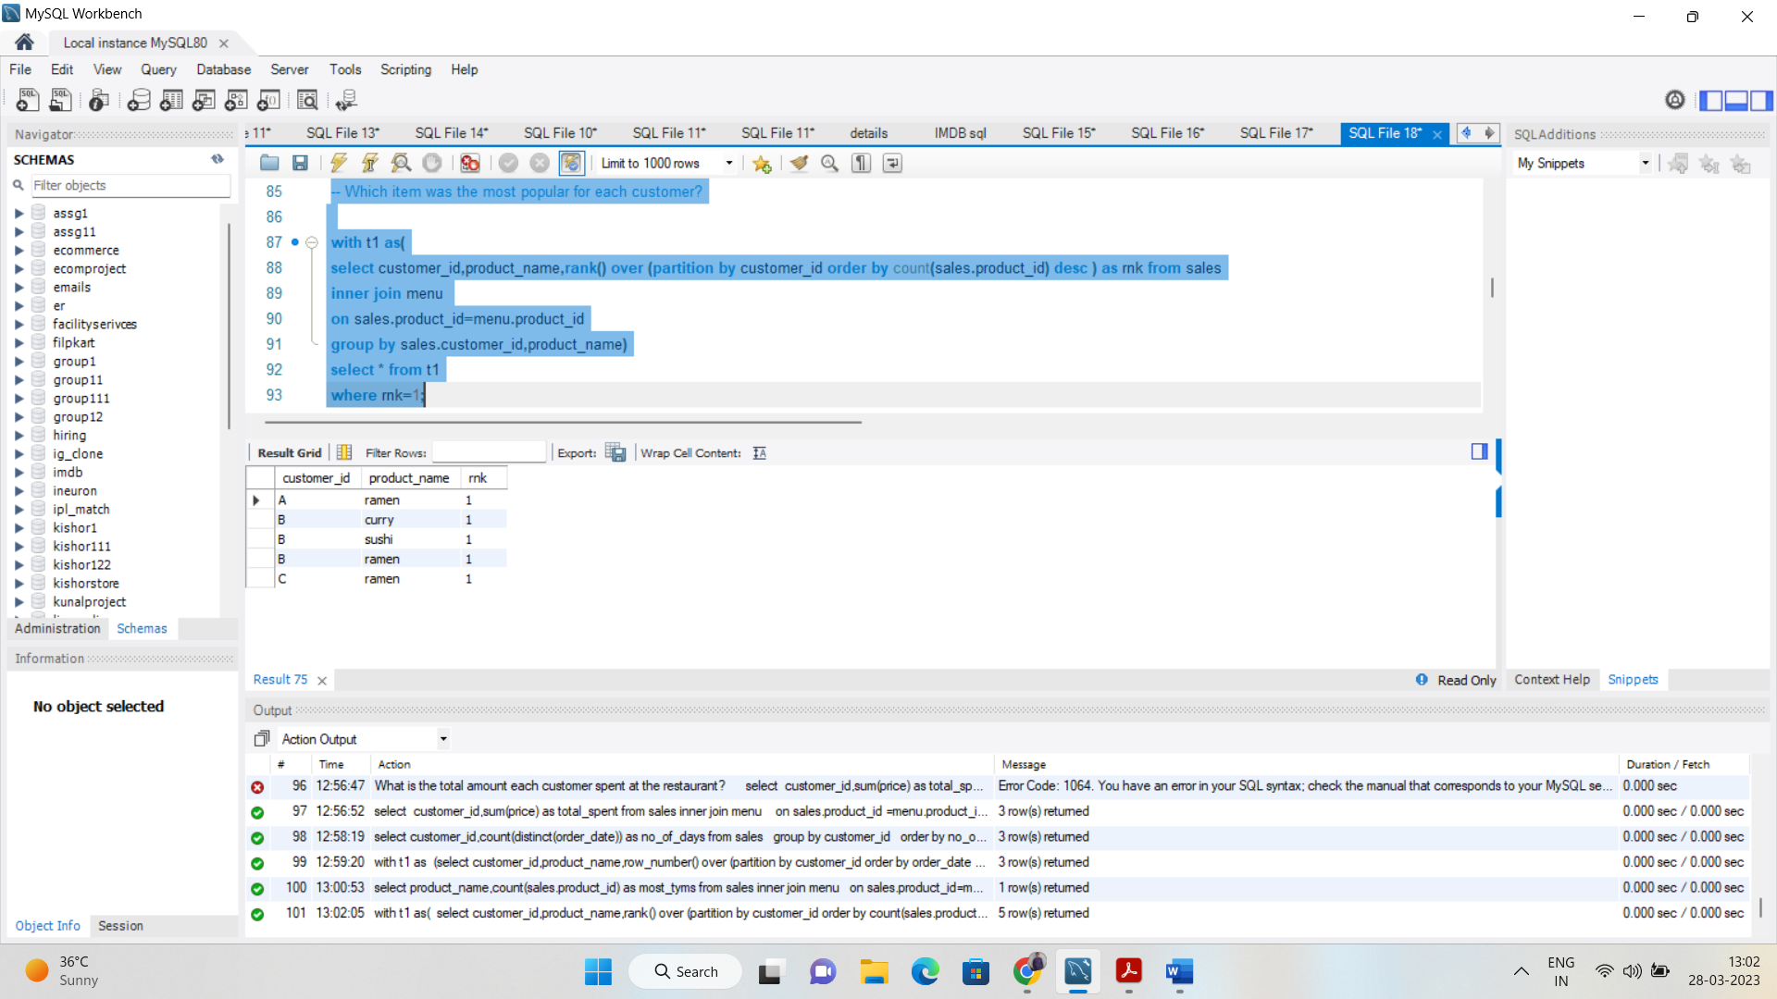

-- Which item was purchased first by the customer after they became a member?

with t1 as

(select sales.customer_id,product_name,sales.product_id, rank() over (partition by customer_id order by order_date,sales.product_id) as row_ from sales

inner join menu

on sales.product_id=menu.product_id

inner join

members

on sales.customer_id=members.customer_id

where order_date>= join_date)

select customer_id,product_name from t1

where row_=1;

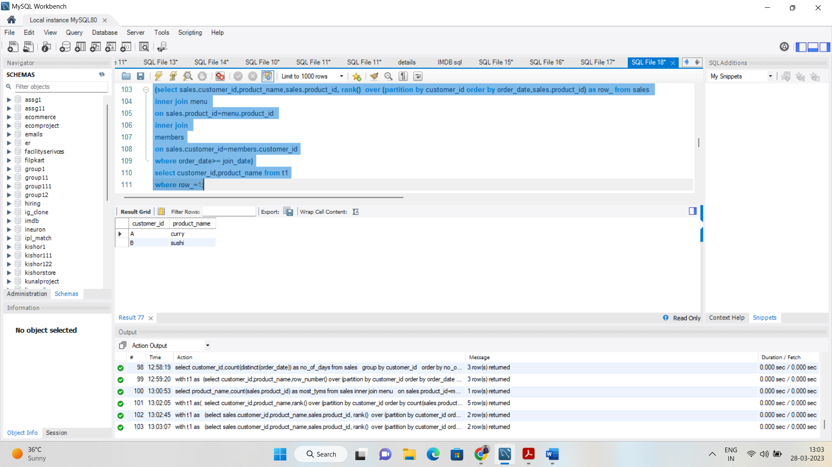

- Which item was purchased just before the customer became a member?

with t1 as

(select sales.customer_id,product_name,sales.product_id, rank() over (partition by customer_id order by order_date desc) as row_ from sales

inner join menu

on sales.product_id=menu.product_id

inner join

members

on sales.customer_id=members.customer_id

where order_date < join_date)

select customer_id,product_name from t1

where row_=1;

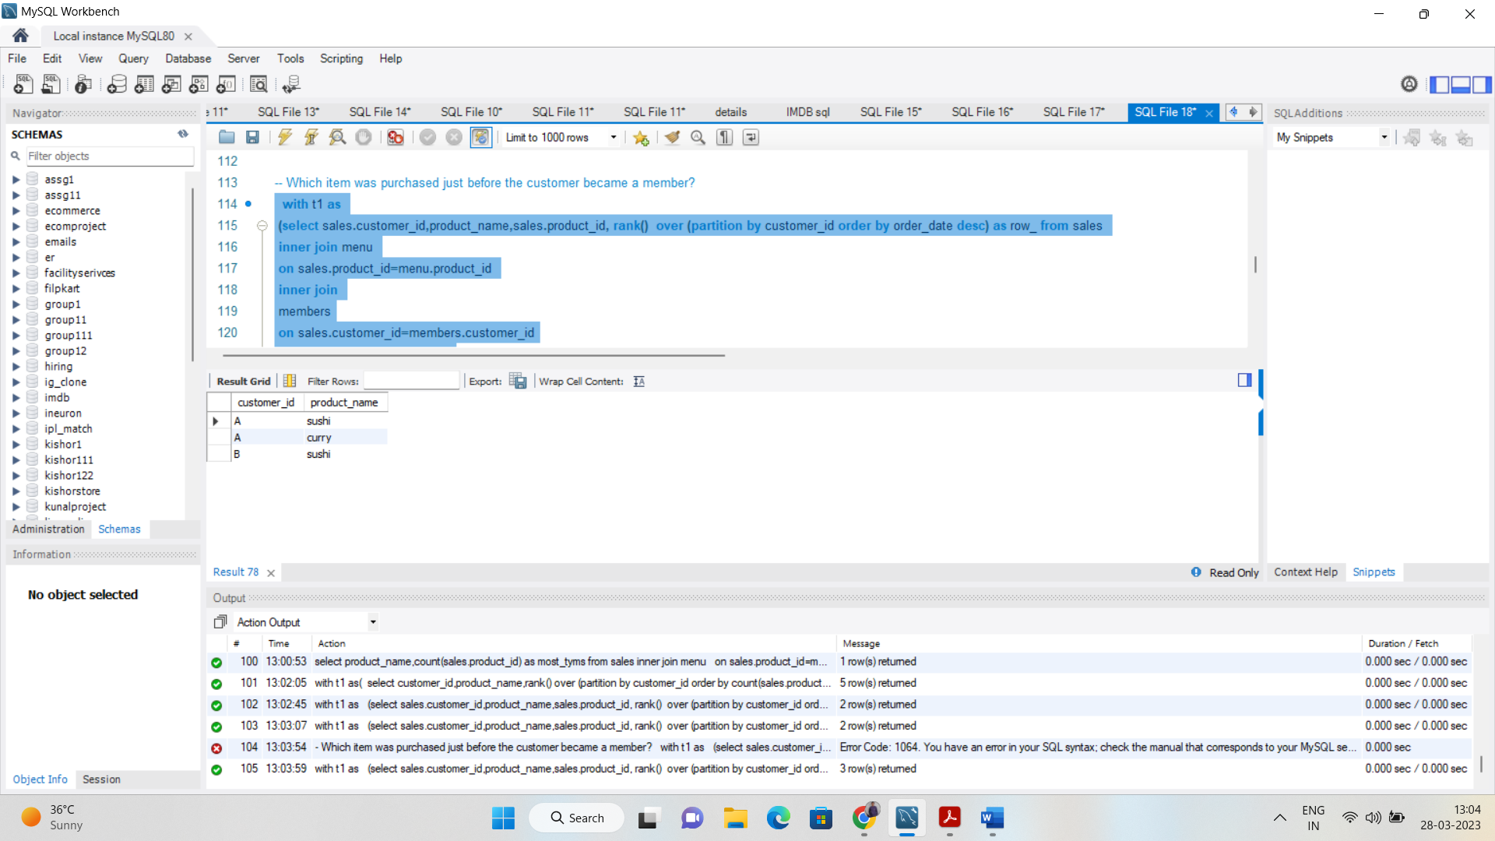

If each $1 spent equates to 10 points and sushi has a 2x points multiplier - how many points would each customer have?

select sales.customer_id, sum(

case

when menu.product_name="sushi" then price*20

else price*10

end ) as score

from sales inner join menu

on sales.product_id = menu.product_id

inner join members on sales.customer_id = members.customer_id

group by customer_id;

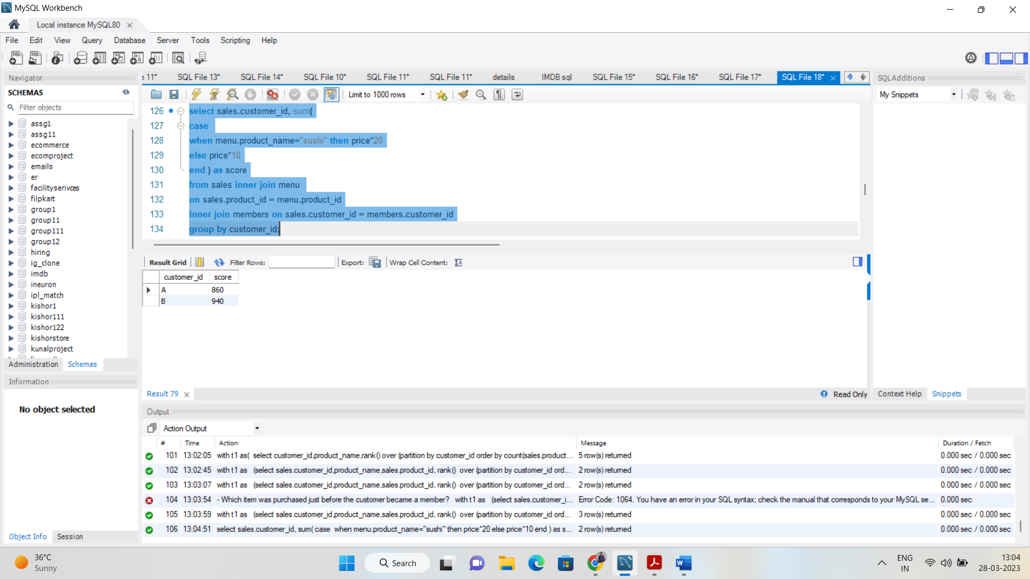

/*In the first week after a customer joins the program (including their join date) they earn 2x points on all items,

not just sushi - how many points do customer A and B have at the end of January?*/

select sales. customer_id,

sum(

case

when order_date < join_date then

case when product_name="sushi" then price*20

else price * 10

end

when (order_date >= join_date+6)then

case

when product_name="sushi" then price*20

else price*10

end

else price*20

end ) as points

from members inner join sales

on members.customer_id=sales.customer_id

inner join menu

on sales.product_id=menu.product_id

where order_date <= '2021-01-31'

group by customer_id;

